# Shadow Eclipse

## Design Document

Steven, Zneeke, Nik_TheGreek, King D, Josef49

### 

### 

**Shadow Eclipse 1**

Design Document 1

Introduction 1

Game Summary Pitch 1

Platform 2

Development Software 2

Genre 2

Concept 2

Gameplay Overview 2

Theme Interpretation (It’s Spreading) 2

Mechanics 3

Art 3

Audio 4

Game Experience 4

UI 4

Controls 4

Gameplay 4

Development Tasks 4

NPC State Machine Flow Chart 6

### 

### 

### **Introduction**

#### Game Summary Pitch

Shadow Eclipse is a 2D top-down action game where the goal is to get to the

objective of the level and then survive waves of enemies.

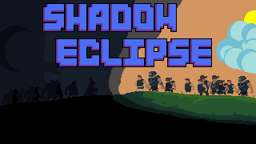

#### Platform

The game is developed to run on PC

#### Development Software

* Godot 4.2.1

#### Genre

Singleplayer, Casual, Action, Top-Down, Survival

### Concept

#### Gameplay Overview

The player will control a single character that will be able to attack and convert

enemies into followers. The followers will be able to be given commands for them

to assist the player. The goal of the game is to get to the end, where once the

goal is “converted” the darkness will start spreading to cover the room, while a

swarm of enemies will attack the player and they will have to survive an amount

of time while protecting the goal and expansion to win.

#### Theme Interpretation (It’s Spreading)

The idea for our game is that the player is a dark wizard trying to dispel the mind

control from the light which has spread throughout the world. The player has to

spread the darkness to free everyone.

### Mechanics

| **Followers**  The player can convert enemies into followers and can command them to follow the player, defend a target, or attack a target. |  |
| --- | --- |
| **Magic**  The player can use ranged magic attacks or a magic laser which uses mana to fight in combat or to convert enemies |  |
| **Conversion**  Use your dark magic to convert enemies and light fountains to allies |  |

### Art

Hi fantasy location and roguelike characters

Sinister Main character Wizard

Enemies: Axe bandit, ranger, armored soldier, werewolf, undead

Objective:Light orb “protecting” city. Once Wizard reaches objective, summon darkness, and darkness spreads

Character will fit within 48x48 square, tiles will be 32x32 at most

### Audio

### Game Experience

#### UI

#### Controls

WASD - Move Character

Left Click - Melee Attack

Right Click - Magic Attack

R - Dark Laser

Z - Command followers to attack target

X - Command followers to go to and defend area

C - Command followers to follow the player

#### Gameplay

Traverse level in average of 10 minutes and Defend objective for 5-10 minutes:

Total 15-20 Minutes

### 

### Development Tasks

| TASK | OWNER | ETA | STATUS | DEPENDENCY | NOTES |
| --- | --- | --- | --- | --- | --- |
|  | KingD |  |  |  |  |
|  | Nikos |  |  |  |  |
|  | *Zneeke* |  |  |  |  |
|  | Steven |  |  |  |  |
|  | Josef49 |  |  |  |  |

======================================================================

1. ~~Game environment for 2d top down. RFC background and character nodes + motion controls~~
2. ~~Camera Tracks Character running around level~~
3. Flow commands also affect following mobs/npcs
4. ~~Mob spawning and motion~~
5. ~~AI behaviors (different AI states)~~
6. ~~Mob commands (defend/follow/attack) to tile/enemy~~
7. Unique mob abilities
8. Player characters can absorb or learn unique mob abilities
9. ~~Melee attack/magic mechanics for both player character and mobs~~
10. ~~Ranged attack implementations~~
11. ~~Mob health and damage mechanics/animations~~
12. ~~Hitbox and collisions for mobs/players/map~~
13. ~~Recruitment mechanic with point system (10 points)~~
14. Recruitment minigame unique to mob type
15. Fleshed out Map level with target goal at the end (prison/ bricks/ Magic TORCHES/ levers/ bars/ doors)

NOTE: Target Goal is Light Fountain

1. ~~Wave Defense of Darkness spreading fountain (mobs spawn constantly and attack darkness)~~
2. Spreading darkness interacts with light sources on the map
3. Scoring/Timer system
4. End of Level Report screen
5. Level up rewards (damage/extra health/increased mob cap)
6. ~~Startup Theme Song~~
7. ~~Level 1 Theme song (loopable)~~
8. ~~Melee sound effects~~
9. ~~Ranged sound effects~~
10. ~~Magic sound effects~~
11. Ambient sound effects (doors, levers)
12. ~~Hit sound effects~~
13. ~~UI Health/Mana/Recruitment indicator/mini map~~
14. ~~Start Screen~~
15. Save/Load Mechanic
16. Options/configs
17. Pause Screen
18. Ingame Timer (maybe hidden) Shown depending on player actions
19. ~~End of Game screen + theme~~
20. ~~Purge Light Fountain Minigame~~
21. Door Pick minigame

### 

### NPC State Machine Flow Chart

Mind states:

| Spawn | Idle | Combat | Hurt | Death |
| --- | --- | --- | --- | --- |
| FollowPlayer | FollowTarget | AttackTarget | DefendTarget | SwarmPhase |

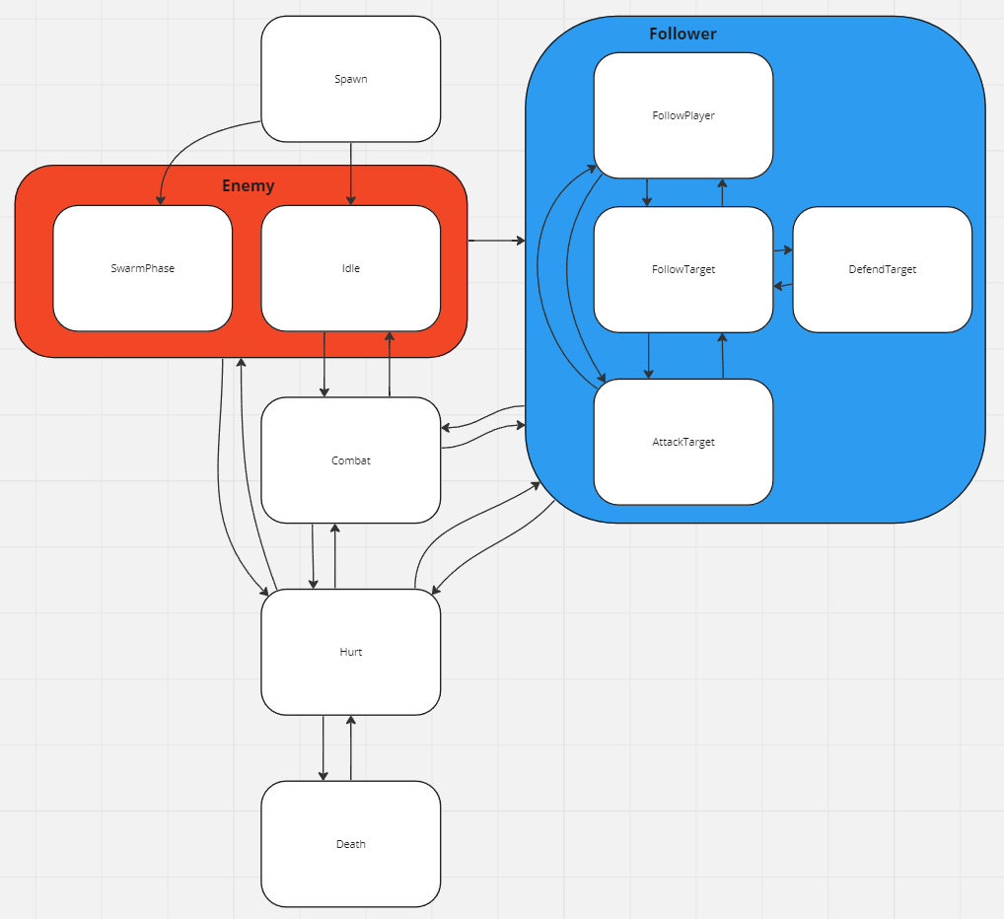

| **State Change** | **Conditions** |
| --- | --- |
| Spawn -> Idle | Automatically when done. |
| Spawn -> SwarmPhase | Automatically when done if entity has swarm_phase property true |
| Idle -> Combat | If near enemy faction |
| Combat -> Idle | No enemies near |
| FollowPlayer -> FollowTarget | Player follow target command |
| FollowPlayer -> AttackTarget | Player attack target command |
| FollowTarget -> FollowPlayer | Player follow player command |
| FollowTarget -> AttackTarget | Player attack target command |
| AttackTarget -> FollowPlayer | Player follow player command |
| AttackTarget -> FollowTarget | Player follow target command |
| FollowTarget -> DefendTarget | Follower reached target |
| DefendTarget -> FollowTarget | Follower too far from target |
| Enemy -> Follower | Player converts enemy |
| Any -> Hurt | Entity gets hit by something |
| Hurt -> Any | Automatically goes back to previous state when done |
| Hurt -> Dead | HP reaches 0 |